

Automatic Barn House Sensor Transport

Sponsor: Dr. Brett Ramirez

Student: Jia Wen Lee

ABE 416

Fall 2018

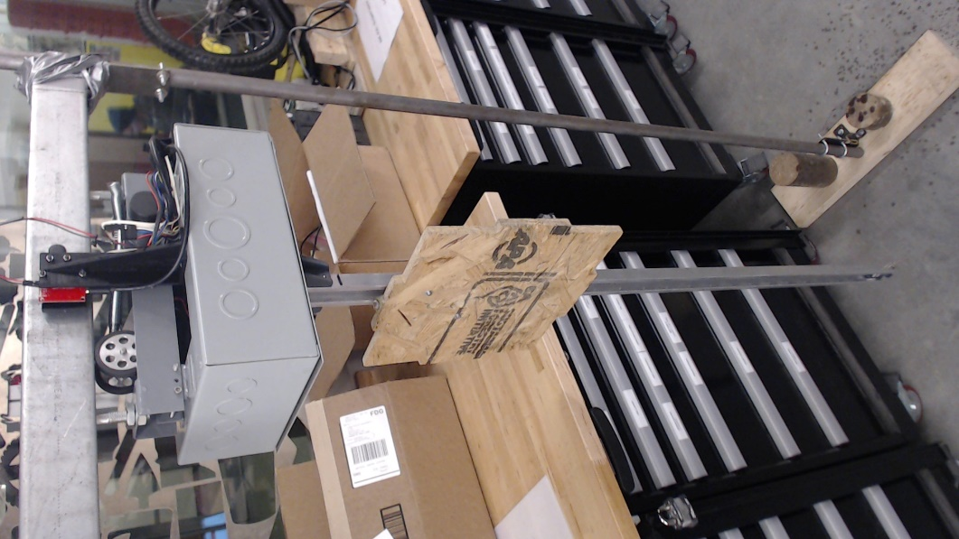

Letter of Transmittal

**4348 Elings Hall  
Department of Agricultural and Biosystems Engineering  
Iowa State University  
605 Bissell RoadAmes, IA 50011**

Dear Dr. Ramirez:

I respectfully submit these documents as the final report of the capstone project. This report contains details of the work that has been done for the automated barn house sensor transport.

This report contains the background on problem, design decisions, mechanical, electrical and software results as well as test data done for the project. The report also provides some of the remaining challenges and future direction of the project.

I hope that the work completed are to your satisfaction. Do contact me should there be any concerns or clarifications that need to be address from this document.

Best Regards,

Jia Wen Lee

Agriculture Engineering: Power & Machinery

# Table of Contents:

Table of Figures: 4

Table of Tables: 5

Project Background: 6

Design Brief: 6

Background Summary by Dr. Ramirez: 6

Problem Definition: 7

Constraints: 8

Criteria: 8

Project Scope: 9

Objective tree: 9

Product Development: 10

Engineering Development – Drive system: 10

Engineering Development – Electronic Housing: 11

Engineering Development – Elevator: 11

Engineering Development – Sensing system: 12

Product Result: 13

Mechanical: 13

Electrical Schematic: 17

Sensor Location: 18

Software: 20

Serial Communication Protocol: 21

Cost: 23

Testing & Result: 24

Trolley Speed & Encoder Test 24

Elevator Speed Test 24

Elevator Timing Test 25

Timeline: 26

Challenges: 26

Conclusion & Future Direction: 27

Conclusion: 27

Future Direction-Mechanical: 27

Future Direction-Electrical/ Software: 27

Future Direction-Economics: 27

Appendix: 28

# Table of Figures:

Figure 1: Dimensional Constraints 8

Figure 2: Objective Tree 9

Figure 3: Barn House Track 10

Figure 4: Electronics Enclosure 11

Figure 5: CAD model 13

Figure 6: Actual System 14

Figure 7: Track to Drive 15

Figure 8: Drive to Enclosure 15

Figure 9: Enclosure to Elevator 16

Figure 10: Electric Schematic 17

Figure 11: Enclosure Sensors 18

Figure 12: Sensor Tags on Track 18

Figure 13: Drive System 19

Figure 14: Elevator Drums 19

Figure 15: Raspberry Pi to Computer VNC Viewer 20

Figure 16: Samba Network File Sharing 20

Figure 17: tkinter GUI 21

Figure 18: General Serial Format 21

Figure 19: Brain Stormed Drive System 28

Figure 20: Brain Stormed Elevator System 29

Figure 21: Trolley Motor 30

Figure 22: Elevator Worm Geared Motor 30

# Table of Tables:

Table 1: Serial Protocol 22

Table 2: Material Cost 23

Table 3: Trolley Test Data 31

Table 4: Elevator Speed Data 31

Table 5: Elevator Timing Distance Data 32

# Project Background:

### Design Brief:

Internal air quality (IAQ) and thermal environment (TE) of a barn are critical to wellbeing of animals housed within the barn. Obtaining accurate information about the air quality within a barn allows for better control of fan and inlet parameters for the barn. Conventionally, multiple sensors are placed in multiple locations of a barn to gain a good measure of the internal condition of a barn. Sensor quantity are however cost prohibitive especially with expensive sensors. Even the cost of cheap sensors would start to add up when trying to accurately sense environmental factors in a barn that’s 600ft x 40ft x 10ft.

A more practical method needs to be devised to sense barn conditions. As such, instead having multiple fixed sensors, a moving platform that carries sensor to different parts of the barn might be more cost effective. This project aims to be a preliminary exploration for the option of automatically carrying a sensor around the barn.

### Background Summary by Dr. Ramirez:

In large, modern facilities both IAQ and TE are dynamic (Ni, et al., 2012; Zhao, et al., 2013) and can vary considerably in the horizontal and vertical directions due to ventilation system design (e.g., inlets, fan capacity, etc.), equipment (e.g., forced air furnace placement, hemisphere fans, etc.), or housing style (e.g., cage-free). The combination of these factors can lead to undesirable regions of poor IAQ and TE that must be improved. This complicated dynamic of spatial and temporal variation is often cost-prohibiting and challenging to detect with standard ventilation controllers, which only have several sensors mounted at fixed locations and can measure just a fraction of the parameters needed to fully describe IAQ or TE. **Considerable time and monetary expenses are needed for labor to individually move each sensor to traverse the entire facility.** The combination of sensors (temperature, humidity, airspeed, NH3, CO2, dust, etc.) needed can be expensive especially when many are required to instrument an entire, large commercial facility. As a result, spatiotemporal uniformity is often inaccurately assessed due to low measurement density and limited time spent in the facility.

### Problem Definition:

As discussed, to ferry the sensor around, Dr Ramirez would like a track system with a motorized trolley built. Sensors would need to move on an x, y plane to capture data around the barn as well as a z-axis to capture data at varying heights. A guide rail would also be necessary to lower and lift the sensors to ensure that the location in which data points is accurate. Full scale trolley must also be able to curve.

Trolley needs to be able to stop at fixed locations on the track and the guide rail, therefore trolley needs to have a localization method. Due to time and personnel limitations, this project will focus mostly on the mechanical aspect of the system. A prototype will be developed so that work can be started on software and mechanical system can be iterated and improved. Since it is a prototype system, it is agreed that I will be working mainly with the trolley and elevator to define track parameters such as weight, size and turn radius. Different tracks will be explored but ultimately scope of this capstone project will not be setting up all 600 ft of track.

After feedback during my capstone presentation, researching on the process of installation of tracks and discussion with Dr. Ramirez. It was decided that finalizing a track system would be outside of the scope of this project.

# Constraints:

* 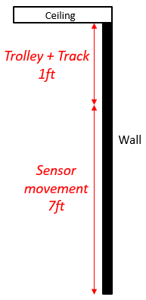Geometrical Constraint
  + Maximum height of trolley and track cannot exceed 1ft.
  + Sensor must be able to move 7ft vertically.
  + Sensors take a 1ft x 1ft x 1ft dimension and is at maximum 6 pounds.
  + Sensor and tracks should be placed close to the wall.
* Environmental constraint
  + Must be poultry friendly, i.e: collision with rail, noise, corrosion, interference with poultry life.
  + Worker friendly. Does not obstruct daily caretaker chores.

Figure 1: Dimensional Constraints

# Criteria:

* Motion of sensor box.
  + Velocity of 100ft/min of trolley along track.
  + Velocity of 1ft/s of sensor vertical movement.
* Trolley should have potential to curve.
* Trolley will be operational throughout the day.
* Must be able to stop at specified locations.
* Works in dirty environment.

# Project Scope:

The primary objective is to create a prototype trolley and elevator system that can carry a set of sensors to specified locations in a poultry barn. Prototype will be made to be as modular as possible for ease of further development. Prototype does not need to be able to operate throughout the day. Detection sensors will be tested to come up with a reliable mechanism for trolley to stop and lower the sensors to specified locations. Trolley track will not be deeply explored in this project. Project would be for research purposes with potential of commercialization in future.

### Objective tree:

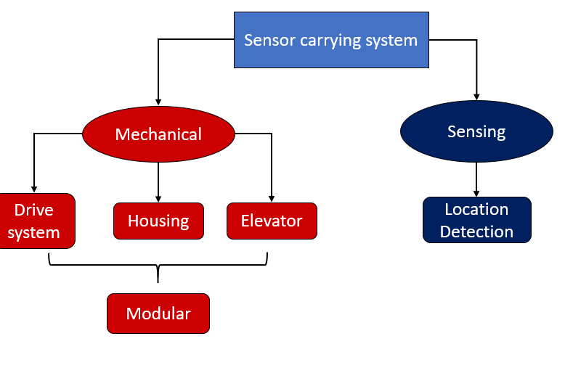

Figure : Objective Tree

# Product Development:

Project spanned two semesters. The first semester involved defining project and identifying requirements for each component of the system. System was broken down into 4 components, drive system, electronic housing, elevator and sensing system. Drive and housing in combination will be categorized as trolley for the remainder of the report. Brainstorming session was done with client on each of these components to decide on design to be built. Manpower limitation and time constraint were considered when making design decisions.

The second semester involved building and testing the selected system.

### Engineering Development – Drive system:

Criteria & Constraints:

* Horizontal movement of 100ft/min
* Shared dimensional constraint with electronics housing of 1ft in height
* Easily detachable from electronic housing
* Easily detachable from track
* Has potential for curved movement

Brainstorm results are in appendix A xxx

After the brainstorm session it became clear the choice of track would be an important factor to consider for the dive design. As the sourcing of track supplier would be a project in itself, it was decided that a standard barndoor track as shown in figure xxx would be used since it can be easily found in regular barn houses, can operate in a dirty environment and would not require extra design work to implement after purchase.

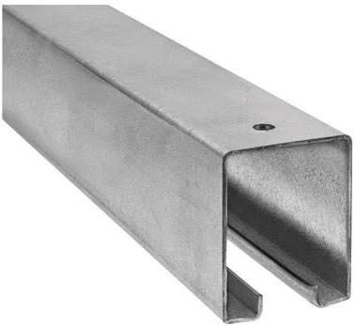

Figure : Barn House Track

A drive system was then developed and iterated through using *SolidWorks.*

Drive wheel was chosen to fit the tracks. Revolution per minute required was determined from diameter of drive wheel.

A 12V DC brushed Motor was chosen based on following requirements:

* 200 RPM
* 5V- 15V
* Length < 2.25in
* Diameter < 1.75mm
* Bi-Directional
* Non-Blocking Code to Run

### Engineering Development – Electronic Housing:

Initially, housing was to be design and manufactured in house, however after several discussions it was decided that an electrical box can be utilized as the housing (figure xxx) as to save development time so that other aspect of the system could be given more time.

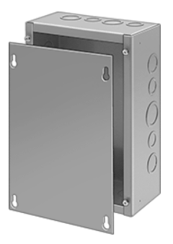

Figure : Electronics Enclosure

### Engineering Development – Elevator:

Criteria & Constraints:

* Vertical movement of 1ft/s
* 4ft test height
* Easily detachable from electronic housing
* Has potential for curved movement

Brainstormed results are in Appendix A xxx.

Initial proposal was to lower sensor box down through gravity and a winch style motor. Due to high dirt environment, gravity alone might not be reliable enough to clean guide rail while moving sensor box. As such a pulley system to pull the sensor box both up and down the guide rail was decided on with a counterweight to lower torque requirements from the motor. Should higher clearance be desired, a telescoping rail could be explored in future.

A 12V DC brushed Motor with worm gear gearbox was chosen based on following requirements:

* + High Torque
  + Low Holding Current
  + 125 RPM
  + As Compact as Feasible
  + Bi-Directional
  + Non-Blocking Code to Run

### Engineering Development – Sensing system:

Multiple sensors were considered for the system including RFID, encoders, hall effect sensors and IMU (inertial motion unit).

RFID:

Radio-frequency identification technology. Receiver can be mount on the trolley with cheap emitter tags stuck on the track in any location desired. Higher frequency RFID systems can go upwards of $1000. Thus, for this application, a cheaper 125kHz system was chosen instead. RFID tags were $4 a piece, therefore in order to save cost at larger scale, another sensor might be considered with RFID being used only as an occasional check on absolute location or to change trolley travel parameters.

Hall Effect Sensors:

Hall effect sensors are relatively cheap sensor that are triggered when close to a magnetic source. Low cost makes it suitable to be used as an elevator limit switch as well as a location indicator for trolley on track.

Relative Encoder:

Encoder would allow monitoring motor speed and motor revolution count. This would allow the system to derive trolley distance travelled and elevator distance traveled.

IMU

An IMU was considered for the project. After deliberation it was decided that since only once axis of the IMU would be useful and none of the rotational axis would be used, other options would be more than enough. Thus, IMU will not be tested in the project.

Microcontroller:

Microcontroller considered would need to be small enough to fit in the enclosure and have at least 3 interrupt pins. An Arduino micro was used as it fits the requirements and multiple units were available for use in from the university.

Wireless Capabilities:

Both the ESP8266 and Raspberry Pi Zero W were considered for wireless communication capability with the project. Ultimately, the Raspberry Pi Zero W was chosen due to ease of network programming.

# Product Result:

### Mechanical:

CAD files are included in the submission USB.

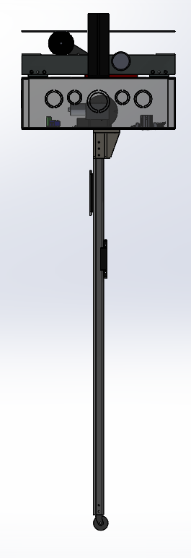CAD model:

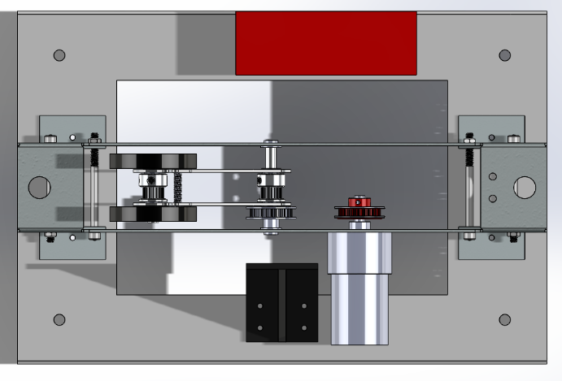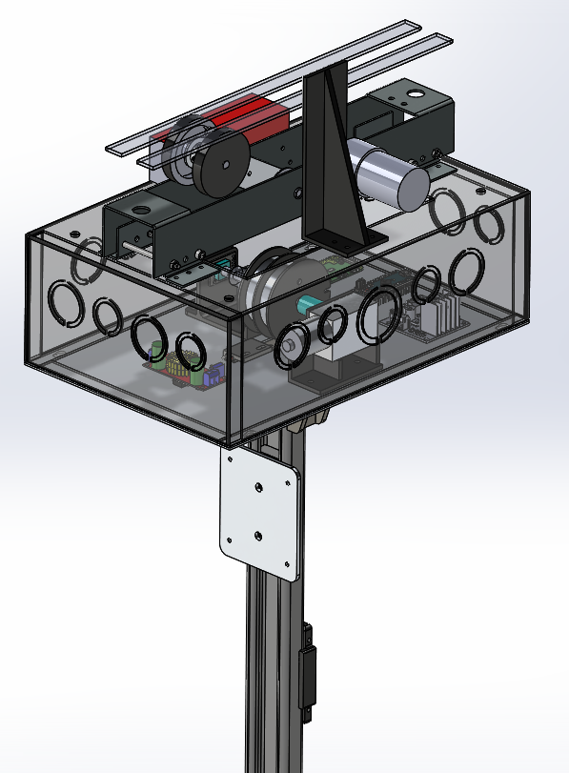

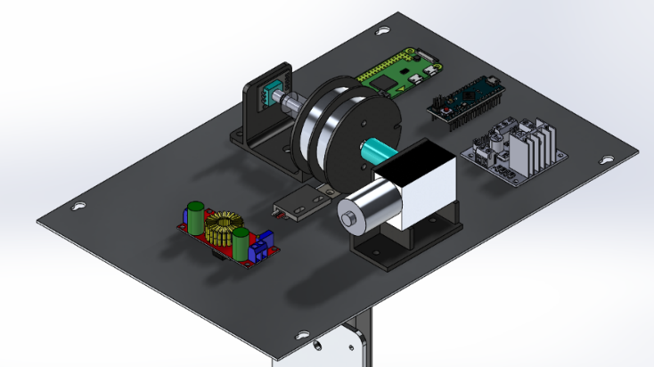

Figure : CAD model

Manufactured System:

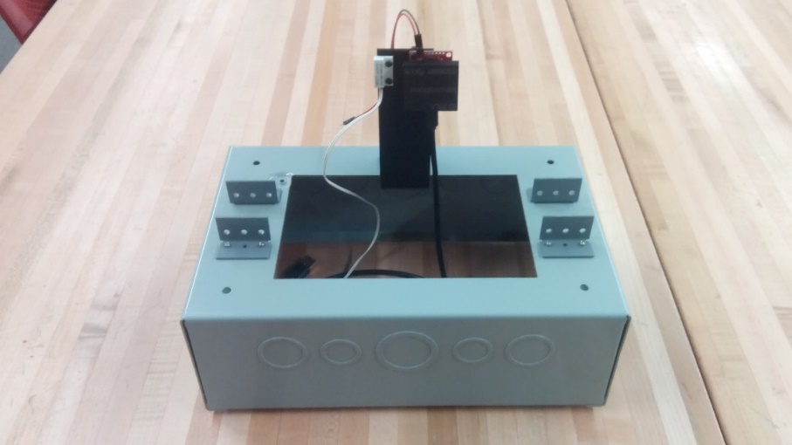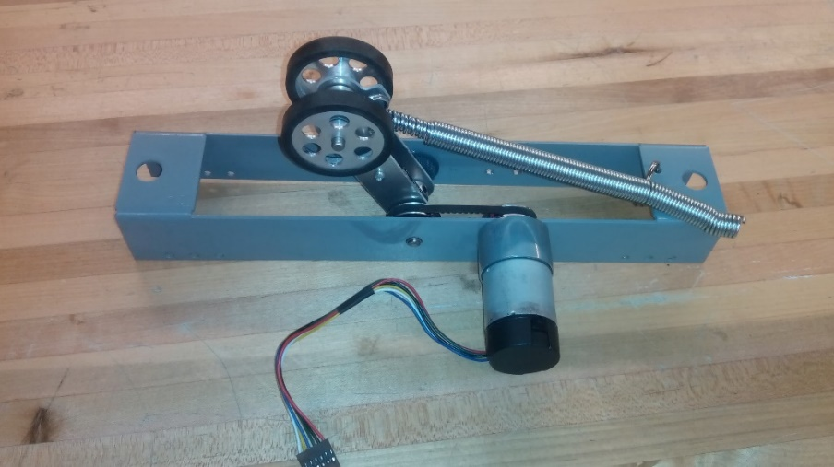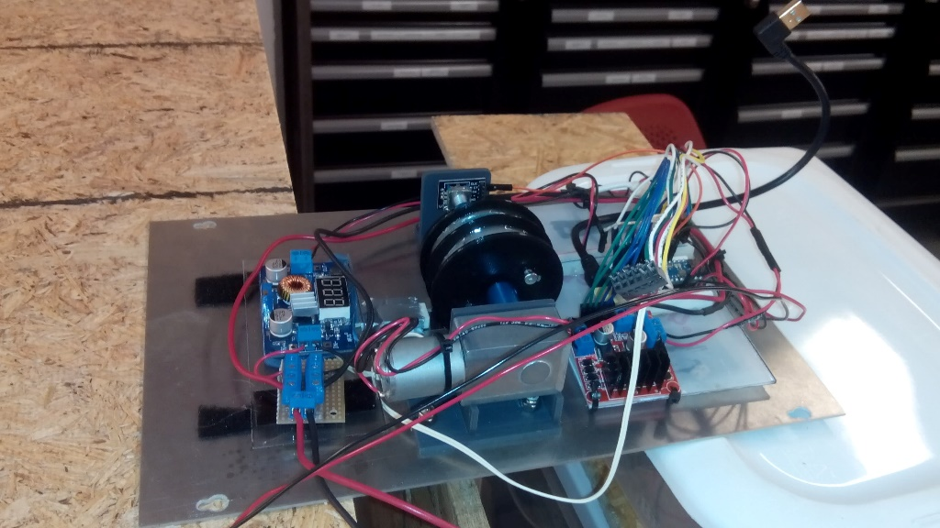

Figure : Actual System

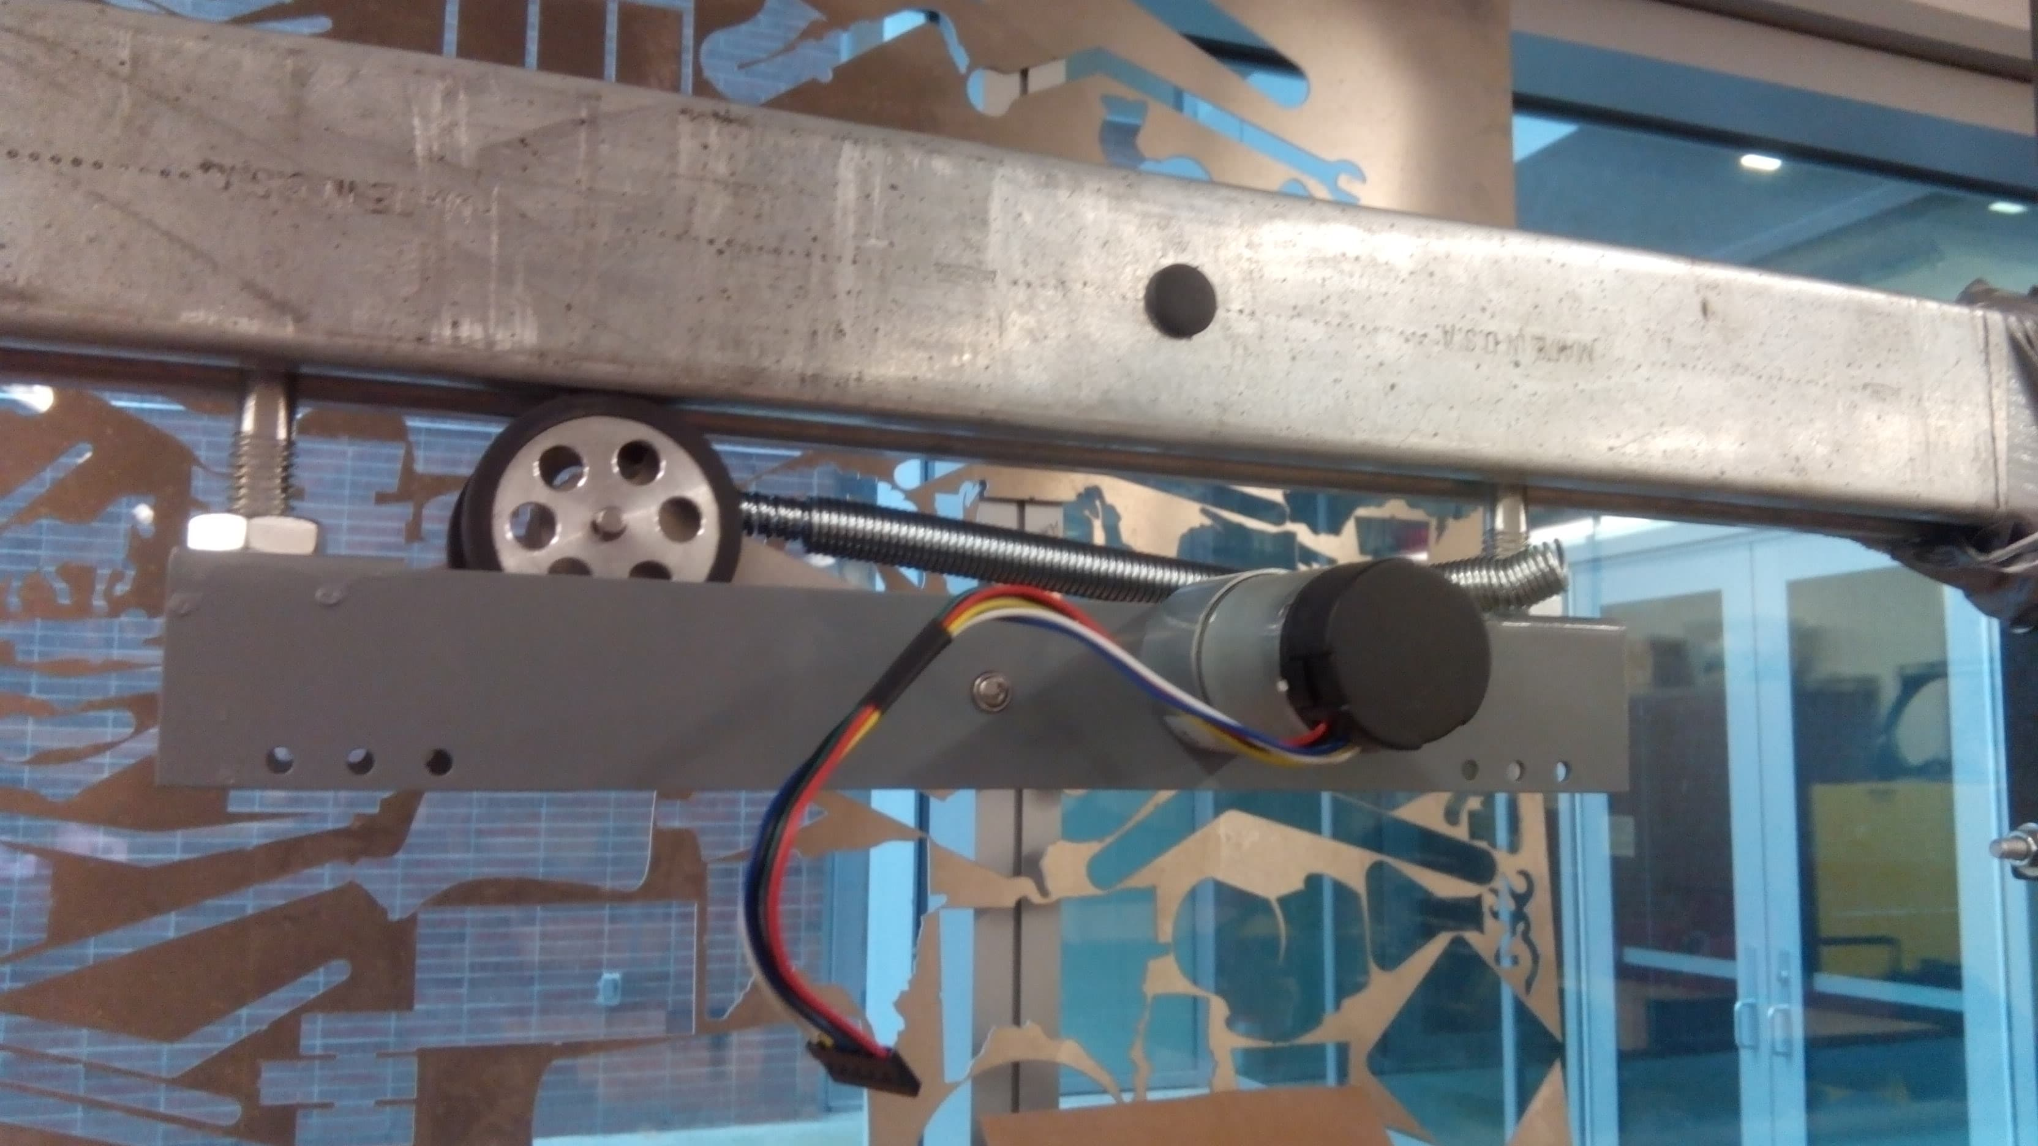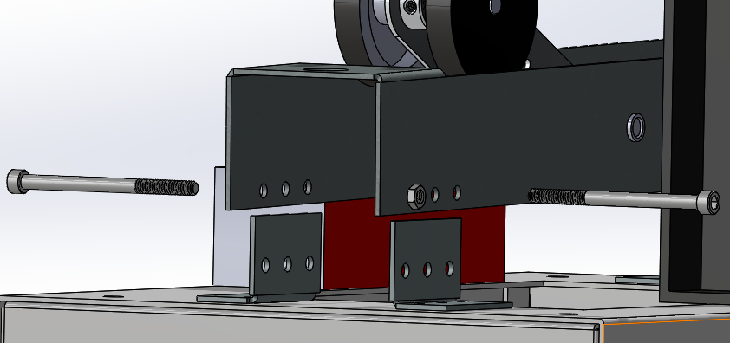System was design to be modular. Track, drive system, housing and elevator can be detached with athe removal of a few nuts and bolts as show in figure 7-9.

Figure 7: Track to Drive

Figure 8: Drive to Enclosure

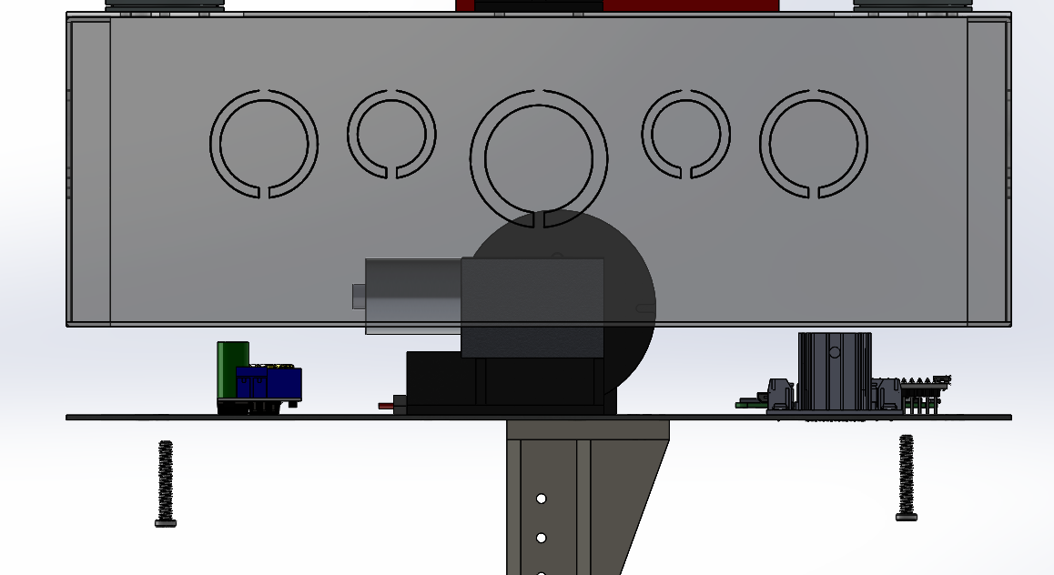

Figure : Enclosure to Elevator

### Electrical Schematic:

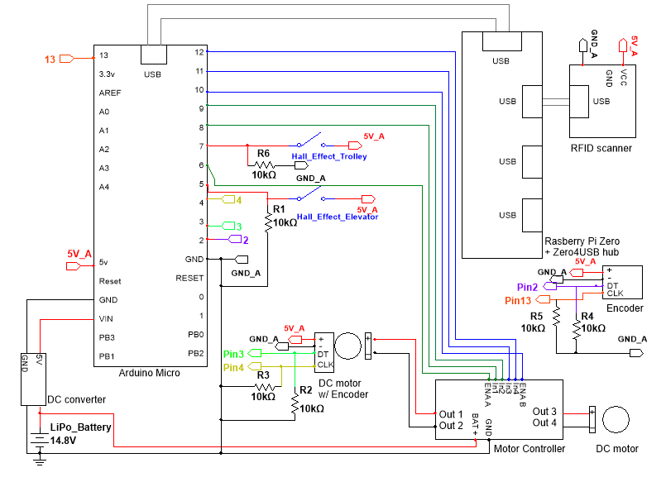

Figure : Electric Schematic

### Sensor Location:

One hall effect sensor and one RFID sensor are located on the top of the electronics enclosure

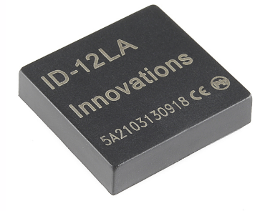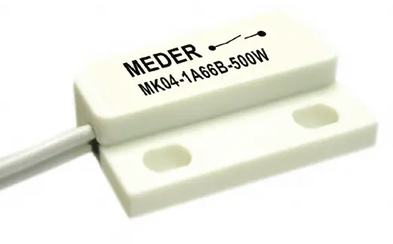 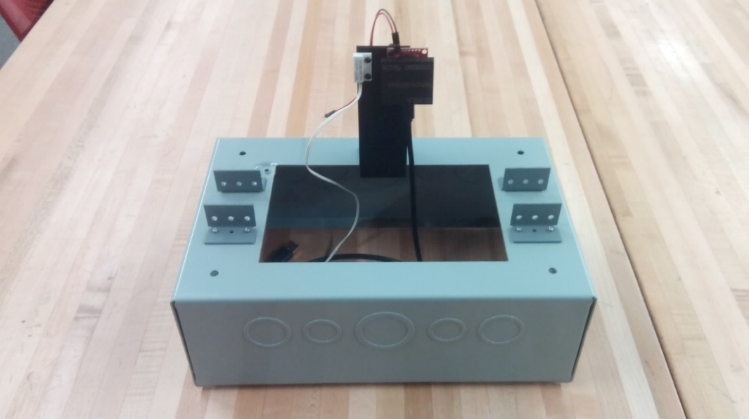

RFID Reader

Hall Effect Sensor

Figure : Enclosure Sensors

Corresponding magnet and RFID tags on the track.

Figure 12: Sensor Tags on Track

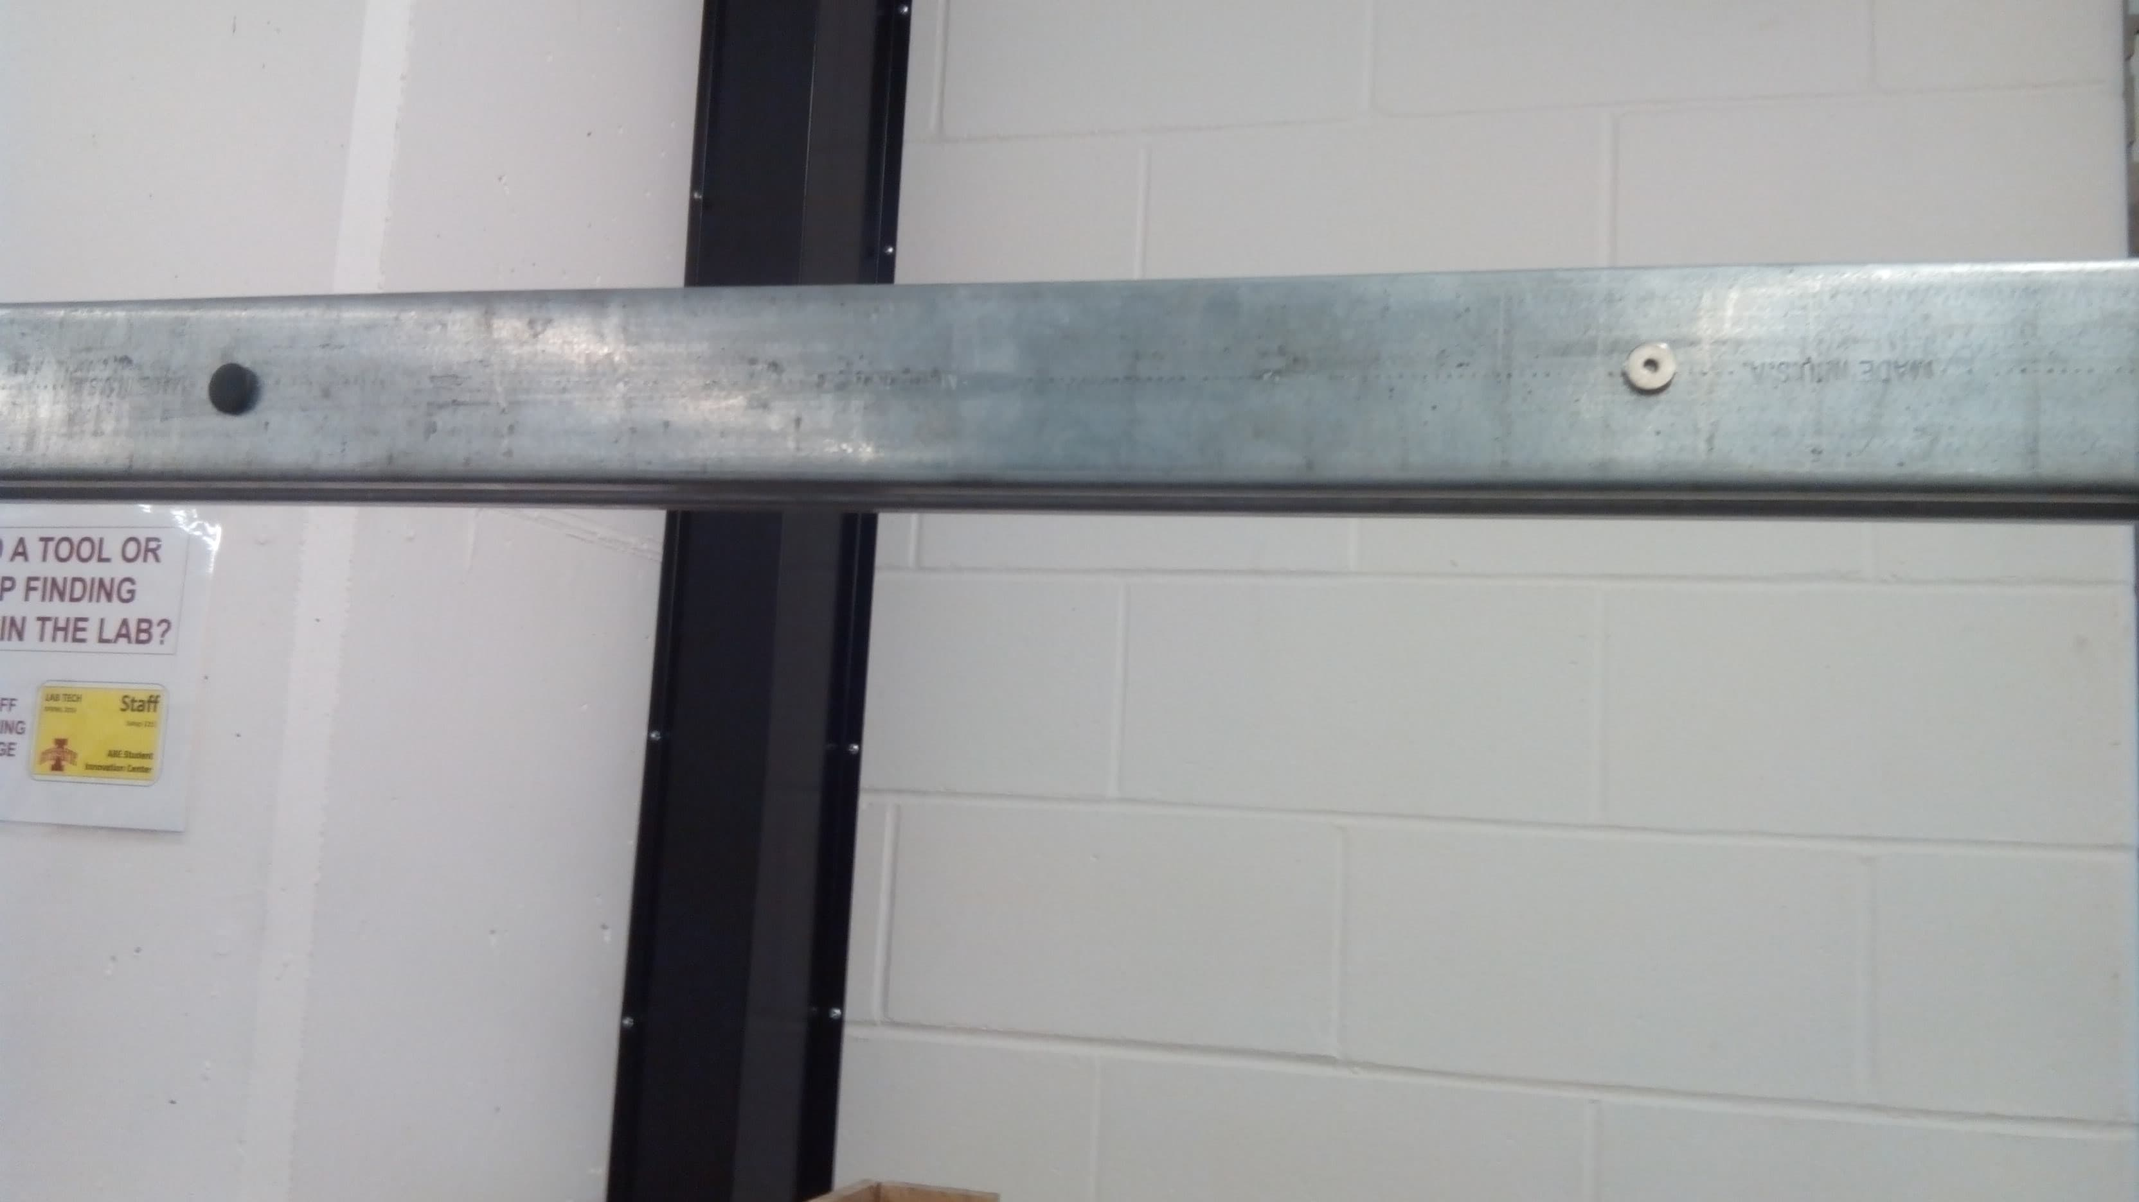

One encoder on drive train and one encoder on elevator. One encoder for elevator limit.

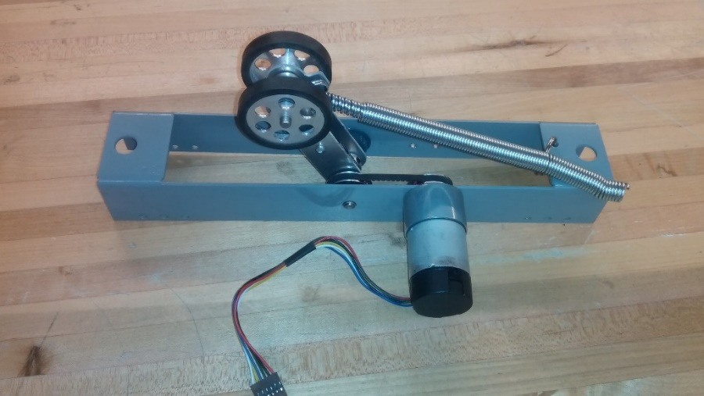

Figure 13: Drive System

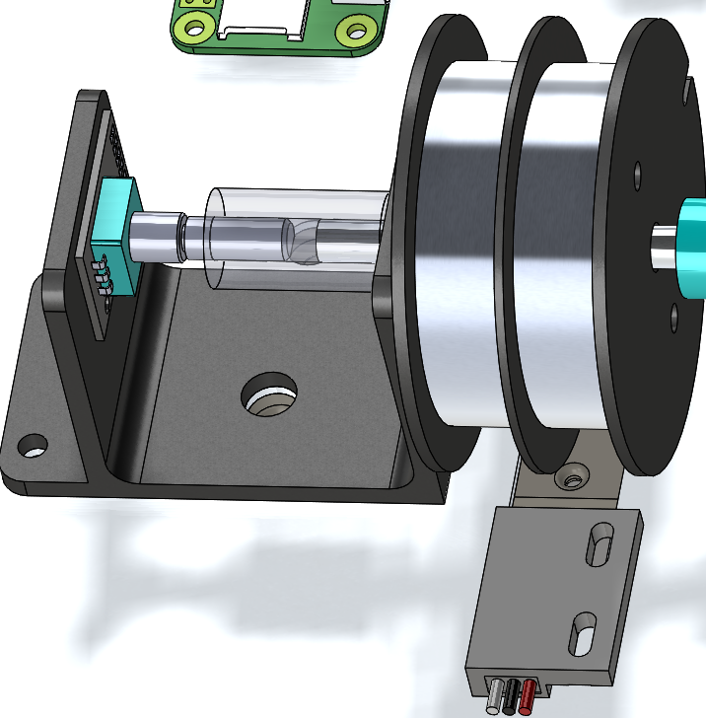

Figure 14: Elevator Drums

Rotary Encoder

Hall Effect Sensor

### Software:

Code for Raspberry Pi and Arduino is included in the USB drive.

A wireless access point was set up on the raspberry pi with IP address of 192.168.4.1 and wireless ID of pi_AP.

Once wireless accesspoint has been started, VNC viewer can then be installed on a computer to remotely access the Raspberry Pi and sreenshare. Wireless accespoint also allows for arduino programming remotely on the raspberry pi.

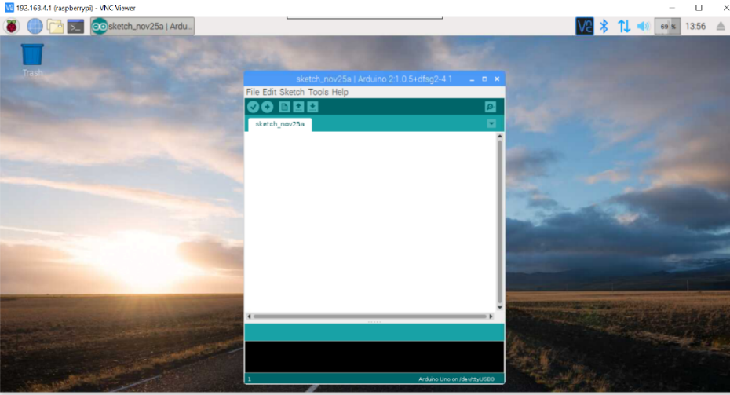

Figure : Raspberry Pi to Computer VNC Viewer

Samba file share has been installed on the Raspberry Pi. This allows for file transfer between Raspberry Pi and another computer.

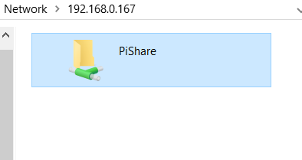

Figure : Samba Network File Sharing

A GUI has been made using python tkinter to connect to the RFID reader and the Arduino. Gui is used to set the ports to connect to RFID and Arduino. Trolley would then have to be initialized to home position. System can be operated in teleop mode to manually control the trolley and elevator. Auto mode will begin the autonomous movement.

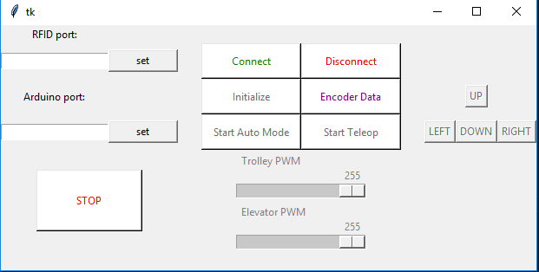

Figure : tkinter GUI

### Serial Communication Protocol:

Arduino and Raspberry Pi communicate through Serial via the USB port. A protocol was created to allow Raspeberry Pi to give instructions to the Arduino.

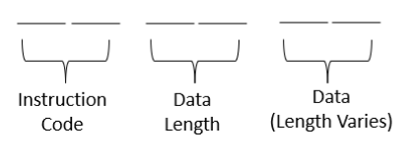

Figure : General Serial Format

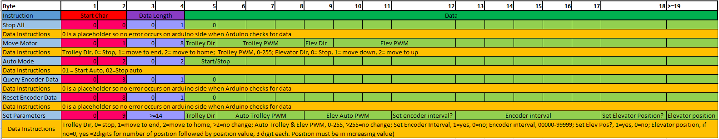

Table 1: Serial Protocol

Parameters that can be changed includes:

* Autonomous trolley speed
* Autonomous elevator speed
* Encoder slow down interval
* Elevator positions

A clearer protocol chart is included in the USB submission.

# Cost:

Full cost breakdown is on the USB submission. Table below shows an overiew of the material cost of the project.

Table 2: Material Cost

|  |  |
| --- | --- |
|  |  |
| Test Track | $10/ft |
| Electronics (Sensor, Motor, Processors) | $199.69 |
| Mechanical(Hardware) | $177.37 |
| Misc (Wires, Header, 3D printed parts) | $32 |
| Total cost (excluding track) | $409.06 |

*Bulk items such as bolts and nuts were counted based on bulk price not unit price used.

# Testing & Result:

### Trolley Speed & Encoder Test

Tolley was ran manually using teleoperation mode. Trolley moved in between two magnets that were set to be two feet apart. When magnet is encountered, system will log time and direction as well as encoder tick. Speed of trolley was calculated from 2ft divided by end time minus start time. Trolley was accelerated to max velocity before trolley encountered first magnet. Experiment does not account for slipping during acceleration. 10 data sets were collected for each direction of trolley travel. Refer to table xxx, table xxx and table xxx in appendix for the data.

Data collected shows as follows:

Trolley speed left :80 ft/min

Trolley speed right :75 ft/min

Mean encoder pulse :2865.9 Pulses in 2 ft

Encoder pulse Standard Deviation :20.88Pulses

As seen from the result, trolley speed is lower than the 100ft/min criteria however velocity is still acceptable. Velocity differs when traveling right and left due to wheel position being closer to the left track roller.

Pulses from drive motor encoder has an error of 0.7% which shows that encoder is consistent so long as no slip occurs.

### Elevator Speed Test

One feet length was measure and marked on the elevator rail. Elevator is then driven up and down in tele-operation mode. Time take for elevator to travel up and down is recorded with a stop watch. Data collected are as shown in table xxx.

Elevator speed up :0.69 ft/s

Elevator speed down :1.28 ft/s

Results show that elevator meets speed criteria of 1ft/s when going down but fails to achieve required speed when going up. This however is due to counter weight being removed as will be discussed in challenges section.

### Elevator Timing Test

Elevator auto mode was set to lower elevator for 3ooms and 500ms. Distance travelled was measure with a measuring tape and recorded. Data collected is shown in table xxx in the appendix.

Result from 300ms test:

* Mean : 5.64in
* Standard Deviation : 0.35in

Result from 500ms test:

* Mean : 7.10in
* Standard Deviation : 0.71in

Standard deviation seems to increase as time traveled increased. It was observed that friction is not constant throughout entire profile of the rail with some sections making more noise that others. This inconsistency contributes to the variance in distance travelled by elevator each time it moves down. Standard deviation is also cumulative if there are multiple stops on the elevator rail. Results show that timing is not reliable and other options such as an encoder for the elevator would be recommended.

# Timeline:

Spring 2018:

* 08 Mar – 16 Mar : Define project
* 16 Mar – 14 Apr : Ideation & Research
* 14 Apr – 02 May : Design prototype and select parts
* 14 May – 16 May : Select hardware
* 15 Jun – 20 Jun : Presentation preparation

Fall 2018:

* 20 Aug – 21 Sep : Design trolley & drive system
* 22 Sep – 23 Oct : Build, redesign system
* 25 Oct – 30 Oct : Code
* 31 Oct – 17 Nov : Wire & test system
* 18 Nov – 22 Nov : Debug code
* 22 Nov – 25 Nov : Collect & analyze data
* 25 Nov – 30 Nov : Documentation & presentation

# Challenges:

Elevator Tensioning:

Counterweight was sliding off the rail and had to be removed since the design did not allow for good tensioning of the string.

Elevator Encoder Broke:

Encoder was not coaxial with the rest of the elevator drive shaft. As such, encoder was damaged by the load force and could not reliably count revolutions of elevator motor. Due to time constraints, design could not be fixed and manufactured in time. Elevator movement had to be controlled using timing instead of encoder ticks.

# Conclusion & Future Direction:

### Conclusion:

Objectives that was set in ABE 415 was achieved. System fell short in the trolley and elevator travel speed however speeds can be easily improved with a different motor. Modular prototype system that can run can be passed on to the client. In addition to the objectives set in ABE 415, system was able to stop at set points on track with an autonomous mode. System also has software developed to facilitate quick coding iteration and development.

### Future Direction-Mechanical:

The most immediate next step is to explore elevator designs. This would include getting a better encoder position and trying different types of elevator. Trolley drive system can be improved to be more robust. Electronic housing could be increased in size to allow more electronics. Lastly, a physical E-stop on the system could be added.

### Future Direction-Electrical/ Software:

Currently the project is running on a li-po battery which can only sustain a high enough voltage for 2 hours. A more continuous power system needs to be implemented. Better motors and encoders can be explored. Electrical controls can be improved with PID control loops. Finally software can be expanded to include more functionality including things like a map of the track, a more complete wireless network solution and better data logging tools.

### Future Direction-Economics:

More research could be done into exploring the monetary benefits such a system could have on an animal indoor enclosure. Once designs have been improved upon, research could be done on the manufacturing cost of the system. A supplier needs to be sourced for the track supply and installation.

# Appendix:

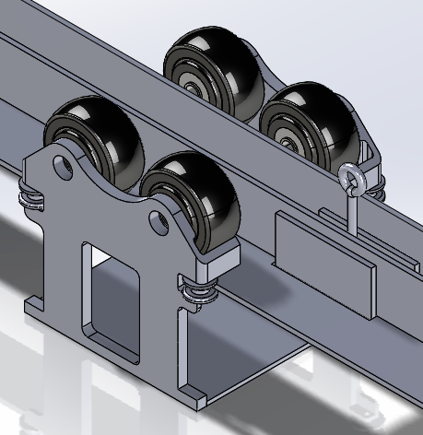

Figure 19: Brain Stormed Drive System

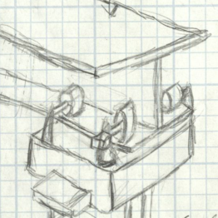

4 Wheel

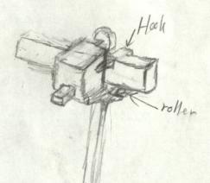

1-2 Wheel Outside

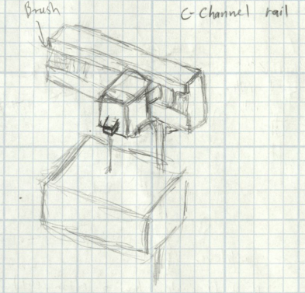

One Wheel in Rail

Figure 20: Brain Stormed Elevator System

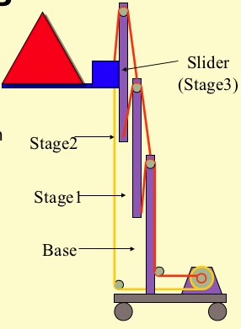

Telescoping System

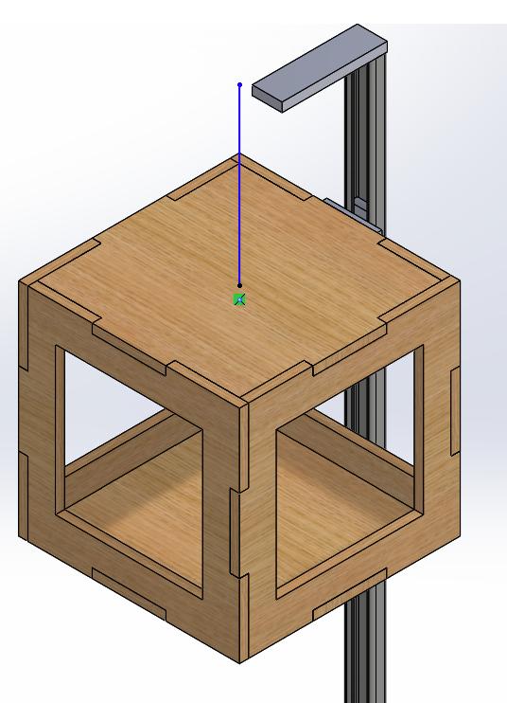

Gravity Driven

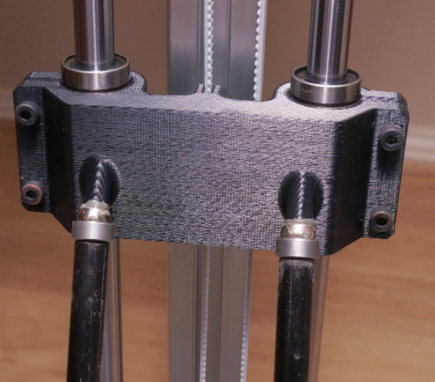

Pulley Driven

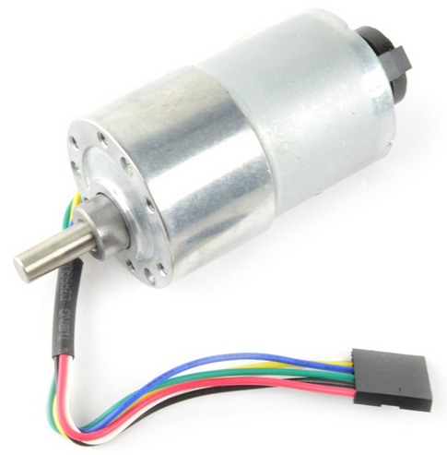

Figure : Trolley Motor

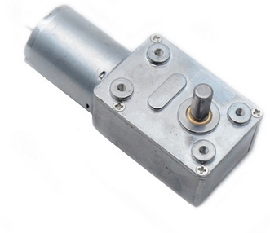

Figure : Elevator Worm Geared Motor

Table 3: Trolley Test Data

|  |  |  |  |  |  |  |  |
| --- | --- | --- | --- | --- | --- | --- | --- |
| To Home |  |  |  |  |  |  |  |
| Start Time(ms) | End time(ms) | Start Tick | End Tick | Time Change (s) | ticks | Speed(ft/s) | Speed(ft/min) |
| 1202639 | 1204275 | 81586 | 84463 | 1.636 | 2877 | 1.222 | 73.350 |
| 1362295 | 1363985 | 91249 | 94127 | 1.69 | 2878 | 1.183 | 71.006 |
| 1442347 | 1443923 | 101610 | 104492 | 1.576 | 2882 | 1.269 | 76.142 |
| 1548988 | 1550618 | 110954 | 113837 | 1.63 | 2883 | 1.227 | 73.620 |
| 1666257 | 1667883 | 124253 | 127139 | 1.626 | 2886 | 1.230 | 73.801 |
| 146583 | 148121 | 11557 | 14441 | 1.538 | 2884 | 1.300 | 78.023 |
| 234000 | 235539 | 22045 | 24925 | 1.539 | 2880 | 1.300 | 77.973 |
| 324249 | 325834 | 35499 | 38380 | 1.585 | 2881 | 1.262 | 75.710 |
| 426718 | 428280 | 53986 | 56868 | 1.562 | 2882 | 1.280 | 76.825 |
| 536448 | 538071 | 68546 | 71434 | 1.623 | 2888 | 1.232 | 73.937 |
|  |  |  |  |  |  |  |  |
| To End |  |  |  |  |  |  |  |
| Start Time(ms) | End time(ms) | Start Tick | End Tick | Time Change (s) | ticks | Speed(ft/s) | Speed(ft/min) |
| 1308299 | 1309800 | 86698 | 89545 | 1.501 | 2847 | 1.332 | 79.947 |
| 1411303 | 1412840 | 96791 | 99639 | 1.537 | 2848 | 1.301 | 78.074 |
| 1486244 | 1487716 | 106709 | 109559 | 1.472 | 2850 | 1.359 | 81.522 |
| 1585676 | 1587194 | 116402 | 119248 | 1.518 | 2846 | 1.318 | 79.051 |
| 1710091 | 1711602 | 131659 | 134517 | 1.511 | 2858 | 1.324 | 79.418 |
| 103012 | 104466 | 6252 | 9113 | 1.454 | 2861 | 1.376 | 82.531 |
| 190676 | 192144 | 17021 | 19881 | 1.468 | 2860 | 1.362 | 81.744 |
| 272783 | 274256 | 31406 | 34267 | 1.473 | 2861 | 1.358 | 81.466 |
| 371163 | 372648 | 42012 | 44814 | 1.485 | 2802 | 1.347 | 80.808 |
| 477346 | 478872 | 61775 | 64639 | 1.526 | 2864 | 1.311 | 78.637 |

Table 4: Elevator Speed Data

|  |  |  |  |  |
| --- | --- | --- | --- | --- |
| Elevator up (1ft) | |  | Elevator down (1ft) | |
| Time(s) | Speed (ft/s) |  | Time(s) | Speed (ft/s) |
| 1.4 | 0.714 |  | 0.72 | 1.389 |
| 1.4 | 0.714 |  | 0.89 | 1.124 |
| 1.6 | 0.625 |  | 0.81 | 1.235 |
| 1.5 | 0.667 |  | 0.82 | 1.220 |
| 1.37 | 0.730 |  | 0.74 | 1.351 |
| 1.52 | 0.658 |  | 0.74 | 1.351 |
| Mean | 0.685 |  | Mean | 1.278 |

Table 5: Elevator Timing Distance Data

|  |  |  |  |
| --- | --- | --- | --- |
|  | Elevator distance (in) | | |
|  | 300ms | 500ms | 500ms |
|  | 6.1250 | 7.9375 | 7.5625 |
|  | 6.0000 | 8.7500 | 7.7500 |
|  | 6.0000 | 8.0000 | 7.6250 |
|  | 5.8750 | 7.2500 | 7.2500 |
|  | 5.8750 | 8.0000 | - |
|  | 5.2500 | 7.0000 | 5.8750 |
|  | 5.3750 | 6.7500 | 6.5000 |
|  | 5.3750 | 6.5000 | 6.2500 |
|  | 5.2500 | 6.5000 | 6.3750 |
|  | 5.2500 | 6.5000 | 6.3750 |
| Mean | 5.6375 | 7.3188 | 6.8403 |
| Std Dev | 0.3466 | 0.7616 | 0.6635 |